Instant Cash Fixed Deposit Account
KBZ Bank’s Instant Cash Fixed Deposit Account is a high interest-earning fixed deposit account that lets account holders obtain interest instantly at the time of account opening.

Eligible Customers
The following types of customers can open the Instant Cash Fixed Deposit Account:
. Individual Account
. Joint Account
. Corporate (DICA), business (Non-DICA), and organization accounts (NGO, INGO, pagoda trustees, universities)

Earn Interest Instantly
No need to wait until account maturity. Get the interest upfront at the time of the account opening.

Minimum Initial Deposit
Open Instant Cash Fixed Deposit Accounts with a minimum initial deposit of 1,000,000 MMK.

Deposit and Withdrawal
Open customer-preferred Instant Cash Fixed Deposit Account types by transferring funds from any ordinary or special cash Call, Current or Savings Deposit Accounts. Similarly, funds upon account maturity are transferred to any designated ordinary or special cash Call, Current, Savings Deposit Account according to Instant Cash Fixed Deposit Account type

Terms of deposit and interests
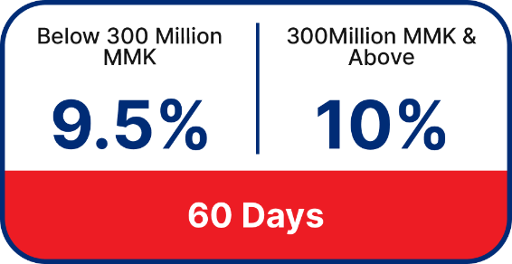
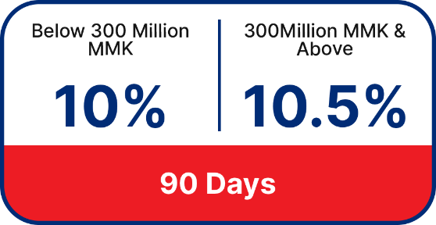

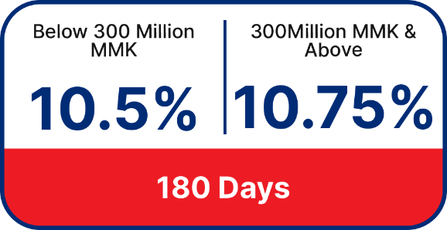
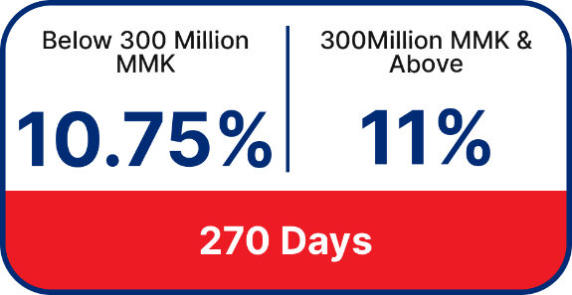
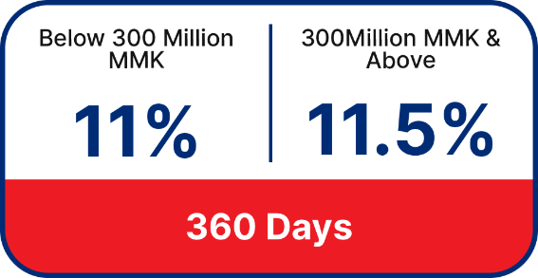
*Effective as of September 1st, 2024

Primary Benefits
High-Interest rate
Earn up to 11.5% p.a. from Instant Cash Fixed Deposit

Earn interest instantly
Get the interest upfront at the time of the account opening.

